**MOUs/ Tie-ups**

|  |  |  |  |  |  |  |  |
| --- | --- | --- | --- | --- | --- | --- | --- |
| **S.No** | **Organisation with which MoU is signed** | **Name of the institution/ industry/ corporate house** | **Year of signing MoU** | **Duration** | **Major activities under each MOU year-wise** | **Number of students/ teachers participated under MoUs** | **Status** |
| **1** | Orixe Technologies Pvt. Ltd | ABES | 2021-22 | 2 years Signed on: 11/11/2021 | Technical session on topic "Advancements in AIML" **Year-2021** | Faculty:16 | Active |
| **2** | Envirozone Instruments & Equipment Private Limited | ABES | 2021-22 | 2 years (Autorenewable) 13-08-2021 | Consultancy in student projects Titled-"IOT based air pollution monitoring system" **Year-2021** | Faculty:1, Students-05 | Active |
| **3** | Marvel Innovative Systems & Technology | ABES | 2019-20 | 1 year (Autorenewable) Signed on: 15/10/2019 | Guest Lecture on "Planar RF devices" **Year-2021** | Faculty:18 | Active |

|  |  |  |  |  |  |  |  |  |  |
| --- | --- | --- | --- | --- | --- | --- | --- | --- | --- |
| **Govt. funded Projects** | | | | | | | | | |
| **S.No.** | **Title of Project** | **Duration of the project** | **Objective** | **Session** | **Amount Sanctioned** | **Funding Agency** | **Date of receipt of Amount** | **Amount received on date** | **Remarks** |
| 1 | Modernization of Microwave engineering lab for Design, Measurement, and testing facility for RF Applications | 2 years | To develop lab with Advanced level RF and Microwave Simulation, Fabrication and Testing Facility for students of UG, PG level | 2019-20 | 14,00,000 | AICTE | 14-01-2020 | 11,20,000 | Completed |
| 2 | Modernization of Electronics Design Lab | 2 years | To develop lab with an Advanced level VLSI based Simulation Facility for students of UG and PG level | 2018-19 | 12,35,000 | AICTE | 03-04-2019 | 9,88,000 | Completed |
| 3 | Research Project-Development of Energy Efficient Air pollution monitoring System using network traffic adaptive WSN. | 2 years | To design an efficient air pollution monitoring system with advanced NI-based hardware | 2018-19 | 5,00,000 | AKTU, Lucknow | 13-05-2019 | 4,75,000 | Completed |
| 4 | Advanced VLSI Design and Applications with hands-on CADENCE Tools | 6 months | To organize STTP on Advanced VLSI design and applications with hands-on Cadence Tools | 2018-19 | 4, 00,000 | STTP under AQIS, AICTE | 05-03-2020 | 4,00,000 | Completed |

|  |  |  |  |  |  |  |  |
| --- | --- | --- | --- | --- | --- | --- | --- |
| **Consultancy Projects** | | | | | | | |
| **Sr.No.** | **Project Title** | **Session** | **Date of Completion** | **Duration** | **Year** | **Funding Agency** | **Amount (Rs.)** |
| 1 | Testing of novel hexagon shaped micro trip antenna | 2021-22 | 17-02-2022 | 6 months | 2021 | GGSIP University, Delhi | 4000 |
| 2 | Fabrication and testing of 2.4GHz Sector and semi-circular Antenna | 2021-22 | 27-12-2021 | 4 months | 2021 | AKTU | 4000 |
| 3 | Testing of pentagon shaped patch antenna | 2021-22 | 18-10-2021 | 1 week | 2021 | GGSIP University, Delhi | 3500 |
| 4 | Design of Multiband Antenna using DRA | 2020-21 | 30-06-2021 | 1 month | 2021 | GGSIP University, Delhi | 5,000 |
| 5 | Design of Multiband Resonator Antenna using Dielectric Resonator | 2020-21 | 16-05-2021 | 1 month | 2021 | GGSIP University, Delhi | 4000 |
| 6 | Fabrication of Antenna Array | 2020-21 | 11-02-2021 | 1 week | 2021 | MJP Rohilkhand University, Uttar Pradesh | 944 |
| 7 | An airfoil fan blade and fan with aerofoil Blades | 2019-20 | 16-01-2020 | 2 years | 2022 | Havells India Pvt ltd. | 1,86,196 |
| 8 | Mechanical Assistant Arm for Wheel Positioning. | 2019-20 | 27-12-2019 | 3 months | 2020 | ACE Honda,Noida | 32,477 |
| 9 | Digital pH meter | 2018-19 | 24-05-2019 | 1 year | 2019 | Aim Electronics and Scientific Co. | 7500 |
| 10 | Digital Colorimeter | 2018-19 | 24-05-2019 | 1 year | 2019 | Aim Electronics and Scientific Co. | 7500 |
| 11 | Hinges/Rotary Handle Operating Life Testing Machine. | 2018-19 | 28-02-2019 | 1 year | 2019 | LGF Sysmac | 6,40,465 |
| 12 | ACDB | 2018-19 | 30-10-2018 | 1 year | 2018 | NRR Power Pvt. Ltd. | 5907 |
| 13 | AJB 15 KW | 2018-19 | 30-10-2018 | 1 year | 2018 | RED Faridabad | 5907 |
| 14 | Solar Power Monitoring System | 2017-18 | 10-05-2018 | 1 year | 2017 | Strolar Mounting Pvt. Ltd. | 5000 |

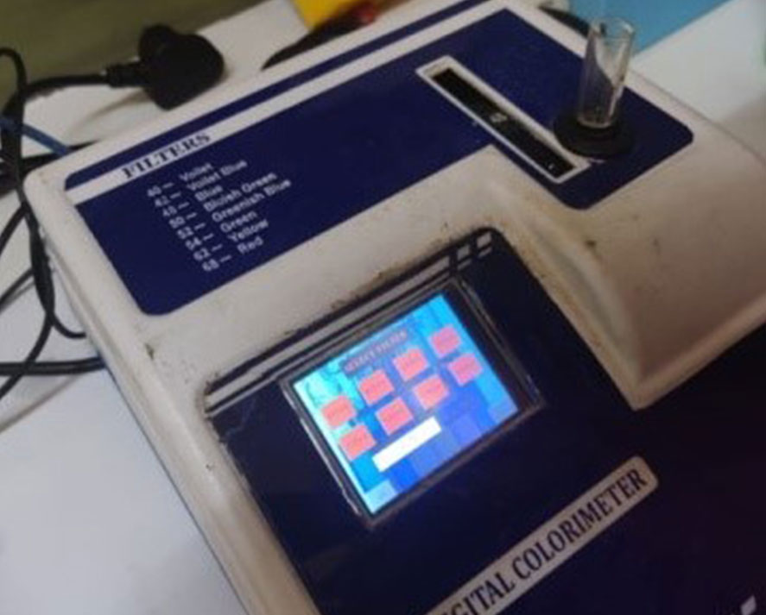

Digital Colorimeter Digital pH meter